1. Create a Car class with the following properties - Make, Model, Current Speed, Engine Size. Use long hand properties, with private attributes and getters and setters. In the program.cs file make use of this class by creating two objects and displaying details on the cars.

1. Add the following methods to the car class
   1. DisplayCarInfo – this should output the car information to the console
   2. ToString – this should return a string which has car information which you should use in a Console.WriteLine statement
   3. Accelerate – this should increase the speed by 10

Use a for loop to increase the car speed in increments of 10 up to 100.

1. Create a class called Bank Account with the following properties – Account Number, Account Holder, Balance. Use shorthand properties. Create a constructor which takes all properties as parameters. Create two bank account objects and display the bank details in your program. Add methods to deposit and withdraw money from the bank accounts. Add a method to display account details and make use of all of these methods using the Console to display the changes.

1. Create an application named TestCashRegister that instantiates and displays a CashRegister object. The CashRegister class contains a field for a total (a decimal) and a field for the number of items (an integer). The CashRegister class has a method called AddItem that takes in a price, adds it to the total and increments the number of items. The class should include properties with only a getter (no setter) to get a Cash Registers total cash price and number of items. Create several CashRegister objects, add a number of items to each and print out the total price and number of items per cash register.

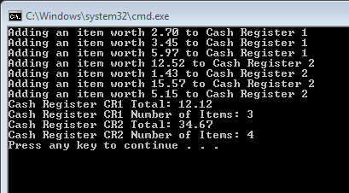

1. The store manager wants to know how much money and how many items have gone through all his cash registers today. Make a copy of the CashRegister class and put it in a new project. Add two static variables, one to hold the total cash amount from all CashRegister objects the second to hold the total number of items from all CashRegister objects. Update the class as appropriate so these two new static variables are updated anytime any Cash Register handles an item. Output these total results.

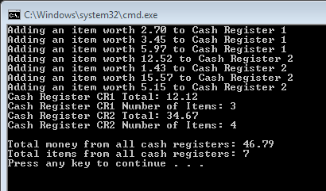

1. 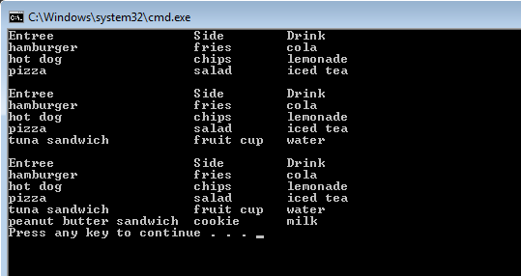Create an application named LunchDemo that declares several Lunch objects and includes a display method to which you can pass different numbers of Lunch objects in successive method calls. This should use the params keyword. Not something we have seen so some research is needed. The Lunch class contains auto-implemented properties for an entree, side dish, and drink.
2. Create a program named **SchoolsDemo** that allows a user to enter data about five School objects and then displays the School objects. The School class contains properties for the School name and number of students enrolled.

Amend the program so that schools can be displayed in order or enrolment. We have not covered this yet so you may need to do some research yourself! Hint – use IComparable.

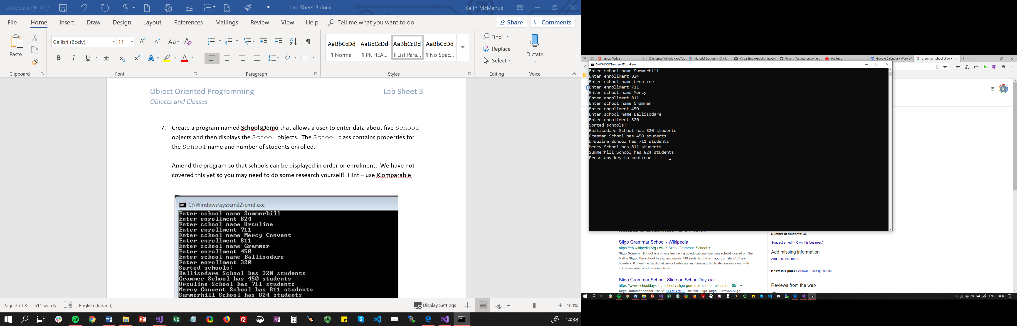

Now add some code to this which asks the user for minimum enrolment to display.

***Note: No video for this question.***